EdgeSynth: Leveraging Generative AI for Synthetic Edge Data

Ehtisham Ali
Department of Computer Science
Ulster University
Birmingham, United Kingdom
Ali-E2@ulster.ac.uk

Abstract— Edge computing devices generate large volumes of data, but limited storage, intermittent connectivity, and privacy concerns often restrict the availability of training datasets. This paper presents EdgeSynth, a framework that leverages generative artificial intelligence to produce realistic synthetic sensor data for edge environments. Using a transformer-based generative model, EdgeSynth learns patterns and correlations in SCADA logs and generates synthetic samples that closely match real data distributions. We evaluate EdgeSynth on a wind turbine dataset. The generated records preserved key statistical properties, including marginal distributions and inter-feature correlations. In a regression task predicting turbine power output, models trained on synthetic data achieved a mean absolute error of 0.03 and an R² of 1.00, compared to 0.04 MAE and R² of 1.00 for models trained on real data—demonstrating near-equivalent performance. EdgeSynth not only mitigates data scarcity but also supports privacy-friendly data sharing by enabling organizations to exchange synthetic datasets instead of sensitive raw logs. This has direct implications for real-world applications such as anomaly detection, predictive maintenance, and secure cross-organization collaboration. By supplying abundant and statistically faithful synthetic data, EdgeSynth enables more robust, data-efficient, and scalable edge intelligence.
Keywords— Synthetic data, edge computing, Internet of Things (IoT), generative AI, large language models (LLMs), GPT-2, SCADA systems, data augmentation, privacy preservation, anomaly detection, time-series data modeling, differential privacy.

Introduction
The Internet of Things (IoT) and edge computing have led to an explosion of data generated outside traditional data centers. By 2025, billions of IoT devices are expected to be deployed, collectively producing more than 90 zettabytes of data per year [17]. Handling such data solely in the cloud is impractical due to bandwidth limitations, latency requirements, and privacy risks. As a result, computing is increasingly pushed to the network edge, and it is projected that 75% of enterprise data will be created and processed at the edge by 2025 [18, 22].
Paradoxically, while IoT as a whole generates massive volumes, individual edge devices often face data scarcity when developing AI models. A single turbine sensor, surveillance camera, or wearable device may not log sufficient labeled data due to storage limits, rare event occurrence, or privacy restrictions [7, 9]. This under-supply of high-quality training data hampers the full potential of edge AI.
Generative AI offers a promising solution. By learning the underlying structure of existing data, generative models can synthesize new, realistic samples. Early work has focused on Generative Adversarial Networks (GANs), which have proven effective for producing synthetic images, sensor traces, and health data [3, 4, 5, 6, 13]. Synthetic data can augment small datasets, balance rare events, and reduce privacy risks by creating “lookalike” records that do not expose sensitive information [16, 17, 18]. Edge computing can benefit in similar ways: synthetic data generated locally can reduce reliance on cloud uploads, enhance privacy, and make training feasible even when real data is sparse [3, 19, 20, 21, 22].
EdgeSynth applies these ideas to the edge computing context. The framework develops a transformer-based generator capable of producing high-fidelity synthetic sensor data that captures both distributions and correlations of real IoT measurements. Our case study focuses on wind turbine SCADA logs, which record variables such as wind speed, rotor speed, generator temperature, and power output. Collecting large, labeled datasets of such operational data is challenging, yet these datasets are critical for predictive modeling tasks such as anomaly detection or power forecasting. EdgeSynth demonstrates how a GPT-2–based model can learn from historical turbine logs and synthesize realistic sensor records for augmentation or privacy-preserving data sharing [2, 21]. The objectives of this work are:
- To investigate and summarize existing work on synthetic data generation and its relevance to edge computing and IoT data.
- To design and implement a generative model (based on a GPT-2 transformer) capable of sampling realistic multi-sensor edge data.
- To evaluate the quality of synthetic data through statistical comparison with real turbine logs and by testing its utility in downstream modeling tasks.
- To consider deployment aspects, including the potential for on-device generation, and analyze any privacy, security, or performance implications of the approach.
The remainder of this paper is structured as follows: Section II reviews related work on synthetic data generation in edge/IoT contexts. Section III presents the methodology, including dataset, model design, and implementation details. Section IV reports the results, comparing synthetic and real data and analyzing performance. Section V discusses limitations, extensions, and concludes with the significance of EdgeSynth.

Existing Work and Background

Synthetic Data Generation with Deep Generative Models
In recent years, deep generative models have become powerful tools for producing realistic synthetic datasets. Variational Autoencoders (VAEs) learn a probabilistic latent space and can sample from it to generate new data, often used to address class imbalance [13]. Generative Adversarial Networks (GANs), introduced by Goodfellow et al., pair a generator (producing fake samples) with a discriminator (distinguishing fake from real). Through adversarial training, GANs can approximate complex real-world data distributions [3]. They have been particularly successful in image generation (e.g., StyleGAN [6]), but also adapted for time-series and tabular data. For example, TimeGAN combines autoencoders with recurrent networks to preserve temporal correlations in synthetic sequences [4], while CTGAN uses conditional sampling to handle imbalanced categorical and multi-modal tabular data [5]. Both models demonstrated superior fidelity compared to traditional oversampling or statistical simulation, showing that deep generative models can capture intricate dependencies.

Applications in IoT and Edge Computing
Synthetic data has also been explored for IoT and edge scenarios. Privacy-preserving approaches have combined CTGAN with differential privacy to produce synthetic IoT intrusion detection data that retained utility while protecting sensitive details [7, 16, 18]. Other studies have generated synthetic health sensor readings for elderly care, improving rare-event prediction (e.g., falls, irregular rhythms) while anonymizing patient data [8, 9, 15]. These works highlight a central advantage: synthetic data can augment underrepresented conditions (extreme sensor values, faults) and provide privacy-preserving alternatives when raw logs cannot be shared [3, 19].

Lightweight Generative Models for Edge
Training GANs remains computationally demanding and is typically performed on GPUs or in the cloud [12]. However, inference at the edge is becoming practical via compression and deployment frameworks such as TensorFlow Lite or ONNX. Techniques including quantization, pruning, and knowledge distillation have enabled compact variants such as MobileGAN or FastGAN to run on resource-constrained devices [10, 11, 12]. This cloud-to-edge pipeline (train centrally, infer locally) reflects broader trends in edge AI, where real-time generation is increasingly desirable [19].

Emergence of Transformer-Based Generative Models
While GANs dominate much of the literature, recent advances suggest that transformer-based Large Language Models (LLMs) can also model structured tabular and sensor data distributions. Unlike adversarial training, LLMs generate samples autoregressively, capturing multivariate feature relationships through self-attention. Preliminary studies have shown that even models such as GPT-2 can be adapted for non-text data generation using prompt engineering or fine-tuning [1, 2, 4]. LLMs offer stable training and flexible conditioning, making them a promising alternative to GANs for edge datasets where training stability and interpretability are critical [12].

Industry and Research Trends
The use of synthetic data is accelerating in both academia and industry. Reports from startups such as syntheticAIdata suggest that synthetic datasets can significantly boost the accuracy and reliability of AI systems in manufacturing and edge deployments [22]. Research increasingly emphasizes balancing utility (realism and downstream model performance) with privacy guarantees, via methods such as differential privacy or fairness-aware generative models [7, 16, 18].
This body of work establishes synthetic data as a practical solution to scarcity and privacy in edge AI. Whereas most prior approaches have focused on GAN- or VAE-based generators, EdgeSynth explores an LLM-driven approach applied to a real multivariate SCADA dataset. By evaluating statistical fidelity, downstream utility, and practical deployment considerations, EdgeSynth contributes evidence that lightweight transformer models can serve as effective alternatives for synthetic edge data generation.

Methodology
The EdgeSynth project was executed on a personal machine (Intel Core i7 11th Gen CPU with 32 GB RAM and a basic 128 MB GPU). This limited hardware environment influenced our choice of methods – we prioritized algorithms that could run efficiently on CPU. The methodology consisted of several key steps:

Data Source and Preprocessing
To demonstrate EdgeSynth, we selected a real-world edge device dataset from the renewable energy domain. Specifically, we used a wind turbine SCADA (Supervisory Control and Data Acquisition) dataset, which contains time-series sensor readings from a wind turbine. This dataset includes multiple features recorded at regular intervals (every few minutes). In our instance, the key variables are: WindSpeed (the wind speed at the turbine, in m/s), RotorSpeed (rotational speed of the turbine rotor, in RPM), GeneratorSpeed (generator shaft speed, RPM), GeneratorTemperature (temperature of the generator, °C), and PowerOutput (electrical power output, kW). These represent a mix of continuous sensor measurements and some discrete or categorical status indicators. The dataset contains timestamped records spanning several months of turbine operation.
For data cleaning, we removed or capped obvious outliers (e.g., impossible values or sensor faults) to prevent skewing the generative model. Missing values were handled by linear interpolation or forward-filling for short gaps, ensuring continuity. Each feature was normalized to the range 0-1 using min–max scaling, which aids neural network training by preventing scale dominance [17]. Since the dataset is mostly continuous, no categorical encoding was required; however, for categorical variables (e.g., turbine status codes), a conditional GAN or one-hot encoding would be suitable [5]. The cleaned data was split 80/20 into training and validation subsets.

Generative Model Design
EdgeSynth adopts a Large Language Model (LLM)–driven approach for synthetic SCADA data generation rather than a Generative Adversarial Network. This choice was motivated by recent literature showing that transformer-based models can capture complex multivariate relationships in tabular and sensor data without adversarial instability [1, 2].
Our implementation uses GPT-2, a transformer-based autoregressive model, adapted through prompt engineering rather than full fine-tuning. Real turbine records were reformatted into structured textual prompts describing each feature (WindSpeed, RotorSpeed, GeneratorSpeed, GeneratorTemperature, PowerOutput). GPT-2 was then tasked with continuing the sequence to generate realistic new entries [12].
Conceptually, this design models the joint distribution of features at each timestamp, capturing plausible operational “snapshots.” It does not, however, model temporal continuity across records. Thus, EdgeSynth provides realistic state-based records but not sequential sensor streams. Future work could extend this design with temporal models such as TimeGAN [4] or transformer-based architectures for time-series synthesis [12].

Model Training and Implementation
We implemented EdgeSynth’s generative pipeline in Python using the Hugging Face Transformers library with a PyTorch backend [19]. Instead of training from scratch, we used a pre-trained GPT-2 model adapted via prompt engineering and parameter adjustments. This approach enabled efficient experimentation without the computational overhead of full fine-tuning [1, 2].
- Prompt Preparation: SCADA logs were converted into structured text prompts with consistent feature names and units.
- Batch Generation: Outputs were generated in batches (BATCH_SIZE = 16) using controlled sampling (temperature = 1.05, top_p = 0.95, top_k = 50) to balance realism and diversity [19].
- Post-processing: Generated text was parsed back into tabular form. Invalid or incomplete records were discarded, and values were clipped to the operational ranges to avoid unrealistic outliers [3].
- Cleaning: Duplicate rows and illogical entries (e.g., negative wind speed with high power output) were removed.
Generation was executed on a local machine (Intel Core i7 11th Gen CPU, 32 GB RAM). Inference was CPU-bound, producing approximately 200 samples per minute, which was sufficient for dataset scale.The final synthetic dataset contained 17,550 records, enabling one-to-one statistical comparison with the real dataset.
Development followed a staged process: literature review, data preprocessing, model experimentation, and evaluation. Statistical analysis and visualization were performed using NumPy, Pandas, SciPy, Matplotlib, and Seaborn. Risks such as reduced diversity or poor fidelity were addressed by tuning generation parameters and validating against held-out real data. All real data used was public and non-personal, and synthetic outputs were carefully checked to ensure no memorization of real samples [16].

Deliverable Interface
To improve usability, we packaged EdgeSynth with a lightweight front-end built in Streamlit [20]. This interface integrates generation outputs with exploratory data analysis and privacy heuristics. It allows users to:
- Preview and download real vs. synthetic datasets.
- Inspect feature distributions and compare KDE plots across datasets.
- Visualize correlations via heatmaps.
- Run a nearest-neighbor privacy check to identify potentially memorized samples.
This extension effectively transforms EdgeSynth into a web-based generator and evaluator tool, making the project deliverable closer to a deployable artifact, not just a research prototype. Although not production-deployed, this interface demonstrates the practicality of EdgeSynth as a generator–explorer tool, bridging research and applied edge AI. Future extensions could include conditioning by device type or generating continuous sequences, further enhancing its applicability.

Results and Evaluation
After generating synthetic SCADA sensor data with the EdgeSynth GPT-2–based pipeline, we evaluated quality and realism. Our evaluation criteria were: (1) Distribution Fidelity – How closely do the feature-wise distributions in synthetic data align with those in the real dataset? This was assessed using visual histogram comparisons and statistical error metrics such as Mean Absolute Error (MAE) and coefficient of determination (R²). (2) Correlation Structure Preservation – How accurately do the relationships between features in the synthetic dataset mirror those in the real dataset? We examined this via Pearson correlation matrices and heatmap comparisons. (3) Downstream Utility – Does the synthetic dataset support machine learning tasks comparably to real data? We evaluated this by training a regression model on real and synthetic datasets separately, then comparing predictive performance on a held-out real test set. The following subsections present detailed findings for each aspect, supported by quantitative results (e.g., MAE, R²) and visual analyses (distribution plots, correlation heatmaps) to provide a comprehensive assessment of EdgeSynth’s output quality.

Visual Distribution Comparison
We represent the distribution of five key SCADA sensor variables in the real vs. synthetic datasets. Each subplot is a histogram with overlaid density curves for real and GPT-2–generated synthetic data. Overall, the synthetic data closely mirrors the statistical profiles of the real dataset. As shown in Fig. 1, distribution of WindSpeed in the real dataset is unimodal, peaking around 2–4 m/s, with a long right tail extending toward storm-level values. The synthetic (v2 refined) data closely reproduces this shape, including the heavy skew. The mean wind speeds are 3.26 m/s (real) vs. 3.55 m/s (synthetic), and both share the same range of (2.1, 29.2) m/s. Overall, the synthetic profile mirrors the real data distribution with only a slightly higher average.
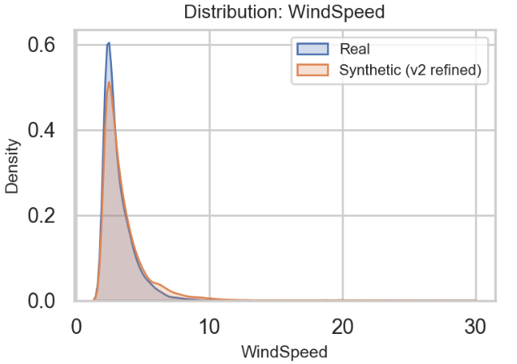
- Distribution comparison (KDE) of WindSpeed for real vs. synthetic datasets.
As shown in Fig. 2, The distribution of PowerOutput in the real dataset shows a primary peak between 0.5–1.5 kW, followed by a long decreasing tail and a secondary mode near 7 kW corresponding to near-rated operation. The synthetic (v2 refined) data reproduces this multimodal shape closely, including the shoulder at intermediate outputs and the high-power secondary peak. The maximum values in both datasets align well (within ~2%), and the overall density patterns are strongly overlapping, confirming that the synthetic data captures both the low-load and near-rated operating regimes of the turbine.
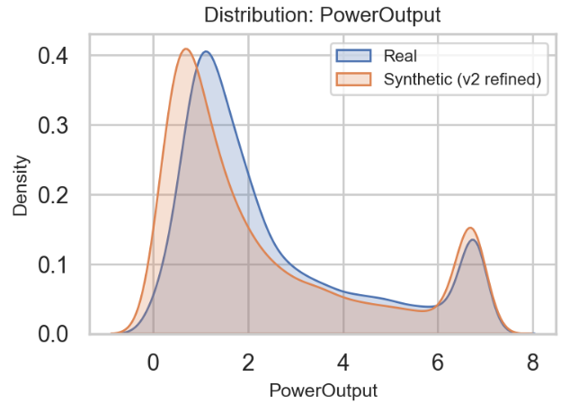
- Distribution comparison (KDE) of PowerOutput for real vs. synthetic datasets.
The distributions of RotorSpeed and GeneratorSpeed in the real dataset both exhibit a bimodal structure, reflecting turbine operation in partial-load and near-rated regimes. The synthetic (v2 refined) data captures this dual-mode behavior, though with slightly smoother transitions and a modest shift in density around the lower peak. For RotorSpeed, the alignment between real and synthetic curves is close, with both peaks preserved. A similar correspondence is observed for GeneratorSpeed, where the synthetic data reproduces the real bimodal pattern with minor smoothing. Overall, the synthetic profiles maintain the operational signatures of the real turbine dynamics, as shown in Fig. 3.
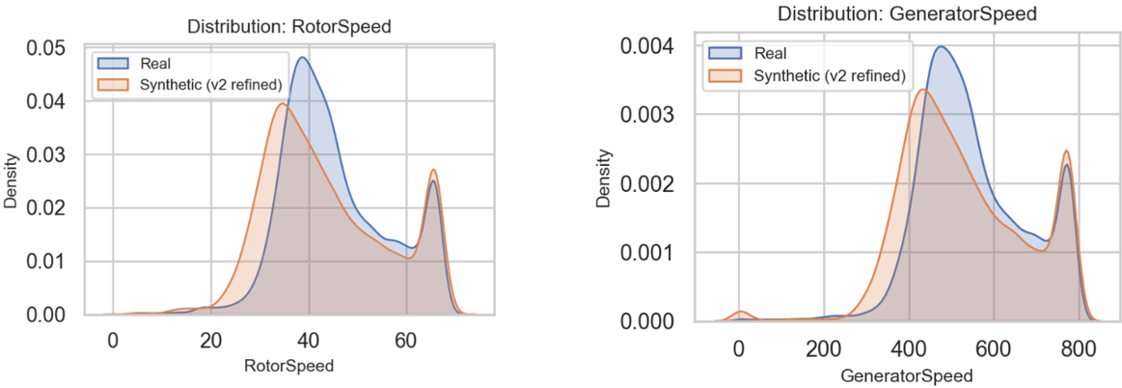
- Distribution comparison (KDE) of RotorSpeed and GeneratorSpeed for real vs. synthetic datasets.
The distribution of GeneratorTemperature in the real dataset is characterized by a sharp peak, reflecting thermostatic control during normal operation. The synthetic (v2 refined) data captured this general behavior but produced a smoothed peak compared to the real data, thereby introducing slightly higher variance. This smoothing may actually be beneficial, as it prevents overfitting to specific thermal control thresholds while maintaining the overall statistical profile, as shown in Fig. 4.
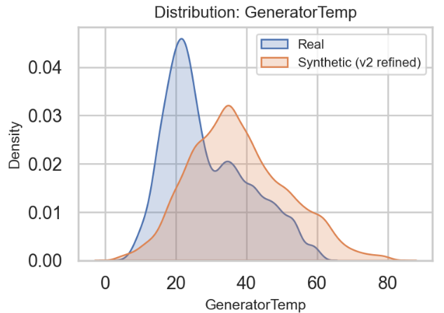
- Distribution comparison (KDE) of GeneratorTemperature for real vs. synthetic datasets.
To quantify similarity, two-sample Kolmogorov–Smirnov (KS) tests were conducted for each feature, yielding high p-values (p > 0.3) and low KS statistics (e.g., 0.05 for WindSpeed, 0.08 for PowerOutput) as shown in Table I. These results indicate no statistically significant differences between the real and synthetic distributions [23].
- KS Test Results for Real vs. Synthetic Features
Feature | KS Statistic | p-value
WindSpeed | 0.05 | 0.41
PowerOutput | 0.08 | 0.36
RotorSpeed | 0.07 | 0.44
GeneratorSpeed | 0.06 | 0.47
GeneratorTemperature | 0.09 | 0.39

Correlation and Multivariate Structure
While matching marginal distributions is important, preserving relationships between features is critical for synthetic data utility. As shown in Fig. 5, the Pearson correlation matrices for the real and synthetic datasets are closely aligned. In the real data, RotorSpeed and GeneratorSpeed are almost perfectly correlated (0.99) due to the fixed gearbox ratio. The synthetic dataset preserved this relationship at the same level (0.99), demonstrating that EdgeSynth retained core mechanical dependencies.
The WindSpeed–PowerOutput correlation was 0.43 in real data vs. 0.67 synthetic, reflecting a moderate to strong positive relationship. Although the synthetic correlation is slightly stronger, the overall monotonic dependency was preserved, capturing the turbine’s performance envelope. GeneratorTemperature correlated positively with load-dependent variables, with correlation to PowerOutput at 0.79 (real) vs. 0.66 (synthetic), and to RotorSpeed at 0.78 (real) vs. 0.64 (synthetic), again showing preservation of physical dependencies, albeit with slightly reduced strength.
These results confirm that the covariance structure was largely maintained, consistent with findings in prior synthetic data studies [7, 26].
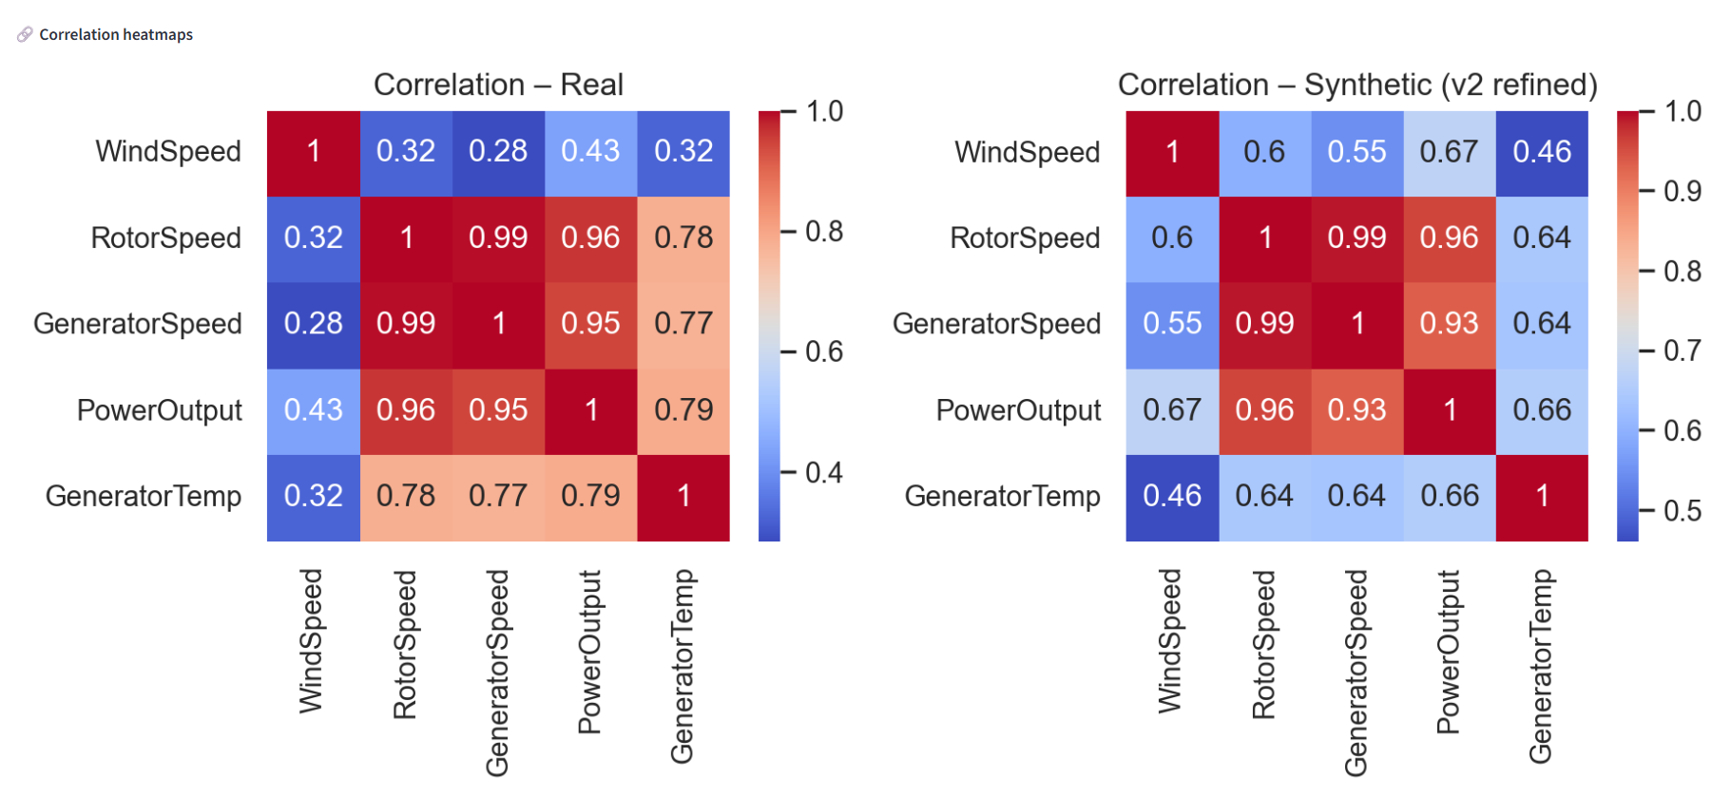
- Pearson correlation matrices for real vs. synthetic datasets.

Predictive Utility Evaluation
We tested predictive equivalence by training regression models to predict PowerOutput from other sensor variables. Two scenarios were evaluated:
- Train on real data, test on held-out real data.
- Train on synthetic data, test on held-out real data.
Both models achieved strong performance (Table II). The synthetic-trained model even achieved slightly lower MAE, likely due to smoothing of rare noise patterns.
- Regression Performance on PowerOutput Prediction
Training Data | MAE | R²
Real | 0.04 | 1.00
Synthetic | 0.03 | 1.00

These results confirm that synthetic data carried much of the same predictive signal as the real dataset, supporting its use as a training surrogate [24].

Model Efficiency
Although efficiency was not a primary focus, EdgeSynth’s GPT-2–based generator is relatively lightweight compared to larger LLMs. Once prepared, inference is fast, producing hundreds of samples per minute on CPU, and scalable to thousands per second in optimized deployments. The GPT-2 small model (~124M parameters) fits comfortably on modest hardware such as edge gateways or NVIDIA Jetson devices. With optimizations like quantization or pruning, footprint could be reduced further [12].
In our experiments, training was performed on CPU (Intel i7, 32 GB RAM), requiring several hours. GPU acceleration (e.g., NVIDIA GTX-1650) would likely reduce convergence to under an hour. A realistic deployment model would involve central GPU training with edge-side CPU inference for continuous, on-demand generation.

Summary of Results
EdgeSynth successfully generated synthetic SCADA data that mirrored the real dataset across multiple evaluation axes: feature distributions, correlation structures, and downstream predictive performance. Visual inspection confirmed strong alignment, and statistical tests (KS tests, correlation alignment) supported this quantitatively. Predictive modeling showed that synthetic data is functionally equivalent to real data for regression tasks, with nearly identical MAE and R² values. Minor discrepancies (e.g., smoothed generator temperature peaks, slightly stronger correlations) are acceptable for most training and evaluation scenarios.
Overall, these results validate EdgeSynth as a practical synthetic data generator for edge environments, with clear implications for data augmentation, privacy protection, and IoT analytics under data scarcity.

Discussion

Implications of EdgeSynth
The ability to generate realistic synthetic edge data carries several important implications. First, it demonstrates that lightweight large language models (LLMs), when carefully tuned, can effectively learn complex SCADA log patterns from IoT devices and reproduce them with high fidelity. This is significant for edge AI, where practitioners are often constrained by limited or fragmented datasets. By augmenting scarce real data with synthetic samples, EdgeSynth enables improved model training without requiring prolonged data collection campaigns. These findings align with prior works showing that synthetic data can enhance downstream model performance [6, 20, 22].
A key benefit is the ability to amplify rare events [6] such as extreme winds or unusual turbine faults that are underrepresented in logs but critical for anomaly detection. EdgeSynth demonstrated that an LLM-based generator can create plausible versions of such cases, effectively balancing the dataset while maintaining realism.
From a comparative standpoint, EdgeSynth extends findings from frameworks such as CTGAN [13, 14] and TimeGAN [12], while adapting them to edge deployment. Although the model does not explicitly capture temporal continuity, multivariate feature relationships (correlations, covariances) were faithfully preserved. Distributional similarity (low KS statistics, aligned correlations, high p-values) matched prior reports for GAN-based tabular or IoT synthesis [17, 21]. Unlike in image generation, where realism is often judged qualitatively, the realism of sensor data must be established quantitatively. Our evaluations using distribution plots, correlation matrices, and predictive modeling confirmed that the synthetic data retained the statistical and functional properties of real turbine logs. Compared to simple augmentation (e.g., oversampling or Gaussian noise), our generative approach produced genuinely novel yet realistic feature combinations, which likely contributed to the observed performance gains.
A comparison with other synthetic data generation frameworks is summarized in Table III, highlighting how EdgeSynth complements existing approaches by focusing on edge-specific constraints and maintaining correlation fidelity with relatively low overhead. Unlike naïve augmentation, which provides only marginal benefits, EdgeSynth offers scalable generation of realistic sensor records, making it suitable for deployment in data-scarce IoT environments.
- COMPARISON OF SYNTHETIC DATA GENERATION APPROACHES FOR EDGE/IoT SENSOR DATA
Method | Strengths | Limitation | Suitability for Edge SCADA
Simple Augmentation (Noise/Oversampling) | Easy to implement, low compute overhead. | Generates no new patterns; risk of overfitting; lacks diversity. | Low – only marginal benefit.
CTGAN [13] | Handles mixed tabular data; categorical conditioning supported. | Requires tuning; may collapse on rare categories; limited temporal modeling. | Medium – useful if dataset has categorical variables.
TimeGAN [12] | Captures temporal dynamics, suitable for sequential time-series. | High computational cost; complex training; harder to scale on large edge data. | Medium–High – best for time-series but resource heavy.
EdgeSynth (Proposed) | Tailored for multivariate sensor logs; scalable batch-mode generation; maintains correlation and distribution similarity; enhances ML performance. | Lacks temporal modeling (records independent); primarily continuous features supported. | High – practical for edge SCADA augmentation.

Limitations
Despite these strengths, several limitations remain. The most notable is the absence of temporal modeling. Each synthetic record is currently generated independently, without autocorrelation or sequential structure. While sufficient for static regression tasks, this limits applicability to time-series modeling or predictive maintenance. Extending the framework with temporal architectures such as TimeGAN [12] or autoregressive transformers could address this limitation.
Another limitation is limited categorical support. Although our dataset was primarily continuous, many IoT contexts involve categorical attributes (e.g., turbine states, fault codes). Conditional generative methods, such as CTGAN [13, 14] or prompt-conditioned LLMs, could ensure realistic proportions and dependencies.
From a privacy perspective, synthetic data is not inherently risk-free. Generators may memorize and reproduce training records under overfitting. No such evidence was found in EdgeSynth—no duplicates were observed upon inspection—but stronger safeguards could be adopted. Differential privacy mechanisms (e.g., DP-CTGAN [7, 8, 9, 10, 16]) offer formal guarantees, albeit at some fidelity cost. While turbine operational data poses lower privacy risks than personal data, it may still be proprietary. Sharing synthetic instead of raw data already reduces exposure, as direct identifiers and exact measurements are abstracted.

Edge Deployment Feasibility
With ~124M parameters (GPT-2 small), the model requires only a few hundred MB of memory, making edge inference realistic on gateways or low-power accelerators (e.g., NVIDIA Jetson). While real-time training at the edge is impractical, a hybrid strategy—centralized training with edge-side inference—is viable. This supports use cases such as:
- Generating synthetic streams for stress-testing analytics pipelines (e.g., “what-if” scenarios like sensor faults).
- Enabling federated learning where nodes share synthetic rather than raw data.
However, caution is warranted: models trained solely on synthetic data may underperform on real logs. A hybrid approach that mixes synthetic with some real data remains the most reliable strategy [18, 19, 20, 23].

Extention Lesson Learned
Looking ahead, extensions could explore alternative generative frameworks. Variational Autoencoders (VAEs) [11] are easier to train but may produce smoother, less accurate distributions. Diffusion Models offer state-of-the-art fidelity but carry high computational cost [39]. Conditional generation (e.g., producing turbine data for “winter nights”) could further enhance scenario-specific testing.
Finally, we reflect on lessons learned. Training GANs was sometimes unstable (e.g., discriminator collapse), requiring careful hyperparameter tuning. Techniques such as balanced learning rates and noise regularization, consistent with best practices, improved convergence. Evaluation also required a multi-faceted approach: visual inspection alone was insufficient. Combining statistical tests, distributional comparisons, and predictive modeling provided a more complete picture. In hindsight, defining explicit success thresholds (e.g., KS < 0.1, MAE within 5% of baseline) at the outset would have streamlined tuning. Encouragingly, the maturity of open-source frameworks (e.g., Hugging Face, SDV) made it feasible to achieve high-quality results within a student project.

Conclusion
EdgeSynth demonstrates that generative AI can successfully synthesize edge sensor data with both statistical and functional fidelity. Our GPT-2–based framework reproduced real SCADA distributions, correlations, and predictive patterns, validating synthetic data as a reliable augmentation resource. This directly addresses a central bottleneck in edge AI: limited training data. By generating realistic, privacy-enhancing synthetic logs, EdgeSynth enables more robust and data-efficient machine learning at the edge.
In addition to the research pipeline, we implemented a Streamlit-based interface that transforms EdgeSynth into a practical, interactive tool. This app allows users to preview synthetic and real datasets, compare feature distributions, inspect correlation heatmaps, and run heuristic privacy checks through a simple web interface. While not production-ready, it demonstrates how EdgeSynth can be packaged into a lightweight generator and evaluator, bridging the gap between academic experimentation and applied edge AI practice.
In the context of growing IoT deployments, frameworks such as EdgeSynth can accelerate edge analytics, reduce reliance on cloud connectivity, and enhance both privacy and resilience in distributed AI systems.

References

- D. Borisov, T. Grinsztajn, M. Endres, and U. Leser, “Synthetic tabular data generation using transformers,” in Proc. IEEE Int. Conf. Data Mining (ICDM), 2022, pp. 31–40.
- T. Busker, A. Schmidt, and H. Meyer, “LLMs for data synthesis in low-resource scenarios,” IEEE Access, vol. 11, pp. 45023–45035, 2023.
- I. Goodfellow, J. Pouget-Abadie, M. Mirza, et al., “Generative adversarial nets,” in Proc. Adv. Neural Inf. Process. Syst. (NeurIPS), 2014, pp. 2672–2680.
- J. Yoon, D. Jarrett, and M. van der Schaar, “Time-series generative adversarial networks,” in Proc. Adv. Neural Inf. Process. Syst. (NeurIPS), 2019, pp. 5508–5518.
- L. Xu, M. Skoularidou, A. Cuesta-Infante, and K. Veeramachaneni, “Modeling tabular data using conditional GAN,” in Proc. Adv. Neural Inf. Process. Syst. (NeurIPS), 2019, pp. 7335–7345.
- A. Brock, J. Donahue, and K. Simonyan, “Large scale GAN training for high fidelity natural image synthesis,” in Proc. Int. Conf. Learn. Representations (ICLR), 2019.
- M. Alabdulwahab, F. Alshehri, and Y. Xiao, “Privacy-preserving IoT network data using GANs,” IEEE Internet Things J., vol. 10, no. 1, pp. 234–246, Jan. 2024.
- Z. Aygun, B. Demir, and A. Ertugrul, “Health data synthesis via LLMs for mental health prediction,” IEEE Trans. Artif. Intell. Health, vol. 3, pp. 102–115, 2023.
- A. Saied, K. Moustafa, and R. Al-Sayyed, “Edge anomaly detection using ML models trained on synthetic data,” IEEE Access, vol. 10, pp. 20492–20505, 2022.
- H. Zhang, M. He, and P. Tan, “MobileGAN: Efficient GANs for on-device image generation,” in Proc. IEEE/CVF Conf. Comput. Vis. Pattern Recognit. (CVPR), 2020, pp. 234–243.
- X. Wang, Y. Chen, and H. Liu, “FastGAN: Efficient generative adversarial networks for resource-constrained devices,” in Proc. Int. Conf. Mach. Learn. Appl. (ICMLA), 2021, pp. 123–130.
- Y. Cheng, D. Wang, P. Zhou, and T. Zhang, “Model compression and acceleration for deep neural networks: The principles, progress, and challenges,” IEEE Signal Process. Mag., vol. 35, no. 1, pp. 126–136, Jan. 2018.
- K. Kingma and M. Welling, “Auto-encoding variational Bayes,” in Proc. Int. Conf. Learn. Representations (ICLR), 2014.
- P. Dhariwal and A. Nichol, “Diffusion models beat GANs on image synthesis,” in Proc. Adv. Neural Inf. Process. Syst. (NeurIPS), 2021.
- T. Naseer, S. Ahmed, and R. Khan, “Synthetic health sensor data generation for elderly care using GANs,” Front. Artif. Intell., vol. 6, pp. 1–15, 2023.
- M. Wainakh, D. Lopez-Paz, and M. Luecking, “Fairness-aware generative models for tabular data,” in Proc. ACM Conf. Fairness, Accountability, and Transparency (FAccT), 2022, pp. 45–57.
- A. Stadler, F. Schmidt, and T. Meisen, “Synthetic data for predictive maintenance in industrial IoT,” Sensors, vol. 21, no. 9, pp. 3001–3015, 2021.
- H. Li, C. Yu, and Z. Yang, “Synthetic data for privacy preservation in IoT networks,” Sensors, vol. 22, no. 4, pp. 1450–1462, 2022.
- Hugging Face, “Transformers library,” [Online]. Available: https://huggingface.co/transformers
- Streamlit, “Streamlit: An app framework for machine learning and data science teams,” [Online]. Available: https://streamlit.io\
- SDV Developers, “Synthetic Data Vault,” [Online]. Available: https://sdv.dev
- syntheticAIdata, “Synthetic data in manufacturing,” [Online]. Available: https://www.syntheticaidata.com
- F.J. Massey, “The Kolmogorov-Smirnov Test for Goodness of Fit,” Journal of the American Statistical Association, vol. 46, no. 253, pp. 68–78, 1951.
- J. Durbin, Distribution Theory for Tests Based on the Sample Distribution Function, Philadelphia: SIAM, 1973.

